## **“ REQUIREMNET SPECIFICATIONS FOR A CHECKERS GAME ”**

**By :- Team Iconic**

**Dated :- 01st November , 2022**

**Mentor :- Mr. Nitin Bhide**

**1. Requirements Analysis:-**

i.) Checkers, also known as draughts, is a group of strategy board games for two players which involve diagonal moves of uniform game pieces and mandatory captures by jumping over opponent pieces.

ii.) Aiming to develop a ‘Checkers’ board game desktop application in which two human players will play against each other and the computer will decide the valid move also computer will detect and declare the winner.

iii.) The problems a user can face about the game is if he or she wants to save a game that is going on at an intermediate stage and he wants to save the game. A user wants to view the history of the games he has played and if users are looking for online tournaments which are not available on a broader scale.

iv.) We are looking forward to creating a desktop application that can be used by any user irrespective of their age group where we can use the real-time databases to save the intermediate stage at which the user exits the game. Databases can also be used to save the history of the games played by the user and can be accessed by him. Real-time APIs can be used to organize contests.

v.) The main objective of this project is going to be to develop a platform where people can come together to play the game which is going to have all the basic features such as saving the game, viewing the history of the game played by a particular user, detecting valid and invalid moves, etc.

vi.) This product can be declared a success if people are able to execute each and every feature of the application and if we are able to communicate with the users and organize a contest.

vii.) Ramesh is tired after working the whole day in the office and wants to relax he wants to play a sort of brainstorming game with his son Rahul. Ramesh wants to play a fair game where only valid moves are allowed and he wants to save the game at the intermediate stage. Ramesh is also looking forward to participating in contests where he can win exciting rewards. Ramesh also wants to view the history of the games played.

Technical Specifications:- Organizing contests and bringing the users on a single platform using real-time APIs.

viii.) There may be many precedents of this application that are available worldwide. Our app in version 1.0 is going to be the same as its predecessor app and version 2.0 will create some features that will differentiate our application from others. We can introduce 8x8 , 10x10, and 12x12 formats of checkers games on a single platform and many more to add on.

**2 . Intended Audience and Intended Use:-**

This Software requirement document can be accessible by my team’s developer, testers, project mentor, testers, and team leader. This document will give a brief overview of our project and help the individual to understand the requirements.

**3. Product Scope:-**

The main objective of this project is to help people relax and play a sort of brainstorming game that will not only make them feel relaxed after their daily routine but also enhance their minds. This product can be introduced on a local level and maximum profit can be earned when it is made flexible for people to use.

**4. Definitions and Acronyms:-**

1. The risk in this project can be stated as the failure in the server when two people try to connect.
2. Sometimes when the user traffic is quite a large app may not be able to handle the user traffic effectively.

**5. User Needs :-**

The given product can be used by any person locally irrespective of their age group. They will use the product as a primary user. Basically it is going to be a desktop application that can be used as any other application which is already available in the market.

**6. Assumptions and Dependencies:-**

We can assume the fact that we are going to use the latest technology that is currently available and is efficient in making the application user-friendly. Currently, we will be basing things on the framework of the window. These assumptions can be taken into account if our product fails to deliver.

**7. Project Overview:-**

I.) Two human players will play.

II) Game will be displayed on the screen.

III) It should be possible to save the intermediate state of the game and resume the game from this saved state.

IV.) Set of rules of the game will be displayed.

V.) Valid moves will be detected by the computer and a warning will be issued if there is an invalid move.

VI.) History of the previous games played by the user will be displayed.

VII.) A leaderboard can also be made by sorting the people on the basis of most number of matches won.

VIII.) A google account can be used to login into the game and save the data.

IX.) Currency systems and different themes can also be added to the product.

X.) Some contests can also be organized between multiple users.

**8. External Interface Requirements:-**

Hardware:- 9:16 Display Resolution Required

Software:- .NET Framework version 3.5 or above

**9. Technical Specifications:-**

Hardware details

i.) Processor:- i3 or above

ii.) Operating System:- Windows 7 or above

iii.) Performance expected power consumption:- 10 to 15 percent/- hour (varies from pc to pc)

iv.) Ram:- 1GB or above

1. **FUNCTIONAL REQUIREMENTS**

**1: Login/Signup**

**Input**: Click on the New Game option.

**Processing state**: The user can start a game from the beginning with all the men, stones, and pawns in their initial position.

**Output**: All the pieces will be at their start position on the board and the game starts.

**2: Statistics**

**Input**: Click on the statistics button.

**Processing state**: User needs to click on this button to view the stats of the games he has played till now.

**Output**: No. of games won, lost, drawn and the winning percentage will be displayed on the screen with the help of graphs.

**3: Saved Games**

**Input**: Click on the Saved games button

**Processing state**: The user can select this button to view the history of saved games.

**Output**: The games which are saved will be displayed with the date and time at which it was saved and the user can resume the game from the same point.

**4: Leaderboard**

**Input**: Click on the Leaderboard button.

**Processing state**: From here user can view his / her position in terms of points compared with other players

**Output**: Your position in the game will be displayed will your fellow players.

**5: Contests**

**Input**: Click on the contests button.

**Processing state**: The user will be made aware of the variables that are organized in a certain period of time maybe a month or in 3 months.

**Output**: All the upcoming contests will be shown to the user.

**6: Profile**

**Input**: Click on the profile button

**Processing state**: Pressing the profile button will let you know the number of matches won, lt, drawn, and winning percentage, and your position in the leaderboard with your name displayed.

**Output**: It will display all of your information about the game.

**7: Themes**

**Input**: Click on the themes button.

**Processing state**: Pressing the themes button will enable you to change the themes of the game such as wooden, black, white, or the default theme.

**Output**: It will display your game as the theme you desire.

**8: Settings**

**Input**: Click on the settings button.

**Processing state**: Pressing the themes button will enable you to control the sound, and music of the game. It will also enable you to reset your game.

**Output**: The game will work at the user’s convenience in terms of sound, music, etc.

**8: Rules**

**Input**: Click on the settings button.

**Processing state**: Pressing the themes button will enable you to view the rules of the game

**Output**: A new window will be opened and you will be able to read all the rules.

**9: Help**

**Input**: Click on the help button.

**Processing state**: Pressing the themes button will give you the basic tutorials of the app.

**Output**: A new window will be opened and you will be able to read all the instructions to use the app.

**10: About Us**

**Input**: Click on the About Us button.

**Processing state**: Pressing the themes button will let you know about the team ‘ ICONIC ‘.

**Output**: A new window will be opened and you will be able to access the LinkedIn profiles and mail ids of all the members of team ‘ICONIC‘.

**11: Exit**

**Input**: Click on the Exit button.

**Processing state**: Pressing the exit button will take you out of the game by asking for three options such as save, save and exit and exit.

**Output**: A new window will be opened and you will be able to choose the option of your choice and exit the game.

**11. Future Specifications:-**

i.) All the forms of 8x8 , 10x10 and 12x12 can be implemented on a single platform.

ii.) AI can be introduced for Computer vs Human mode.

1. Online multiplayer options can also be introduced.

**12. UI Design :-**

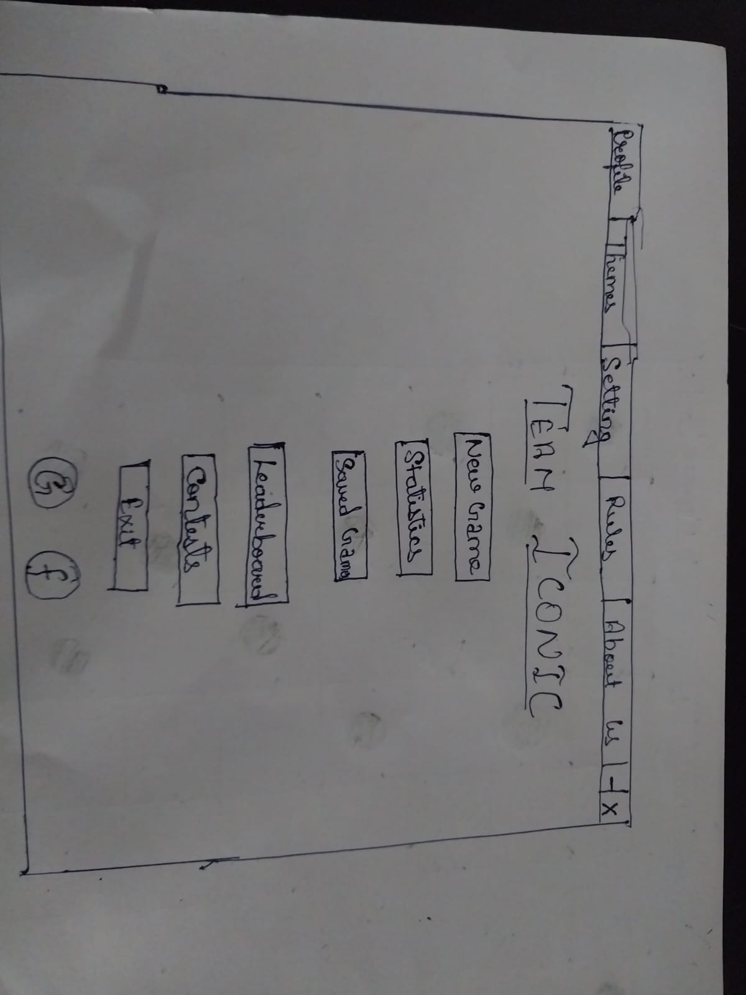

**Next Phase : -**

